Release 1 Artifact 2 : Support Team Members Completing Tasks

I am the most high skilled team members for Ruby on Rails. I support team members , and even help them to complete their task in order to burn down Sprint tasks in expected time. Cloud9 IDE allow me to have direct access to their IDE , then teaching and helping them solving their problem facing in development.

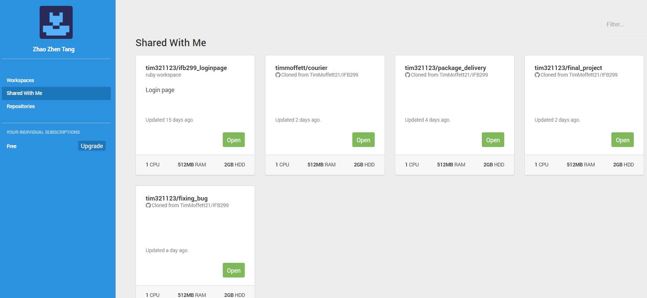

IDE shared by team members in Cloud9

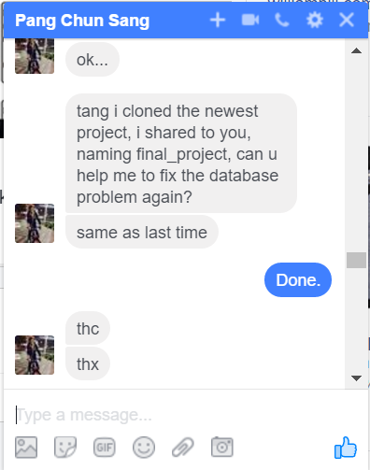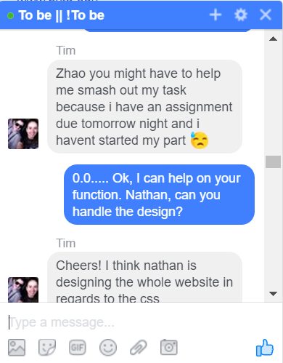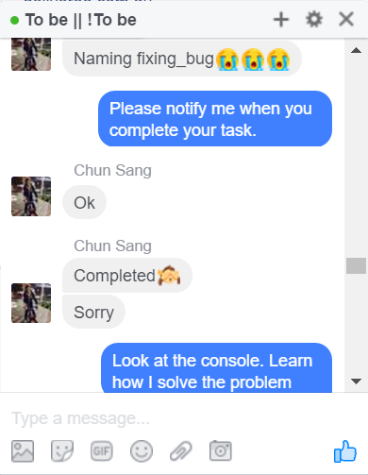

Proof of Helping Team Members Completing their tasks.